1. Create a new process by invoking the appropriate system call. Get the process identifier of the currently running process and its respective parent using system calls and display the same using a C program.

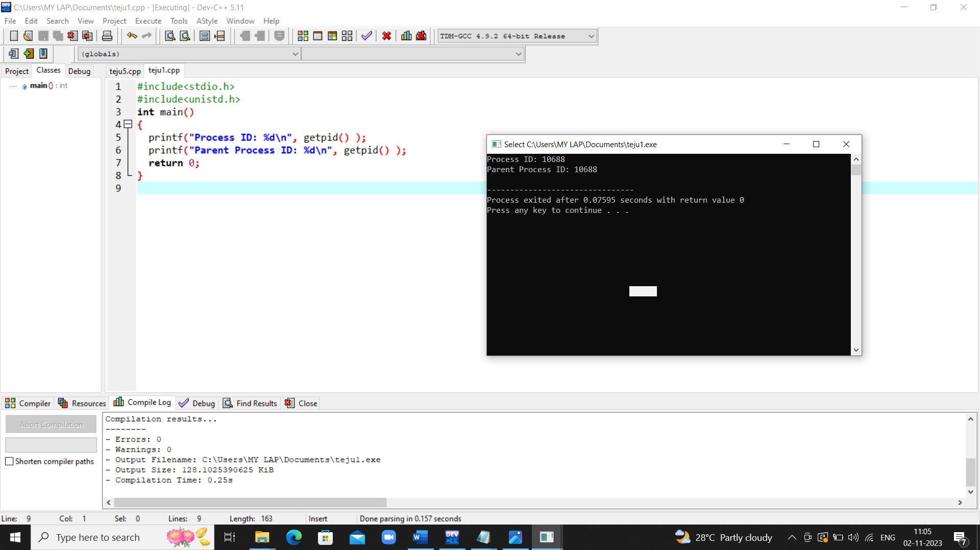

2. Identify the system calls to copy the content of one file to another and illustrate the same using a C program.

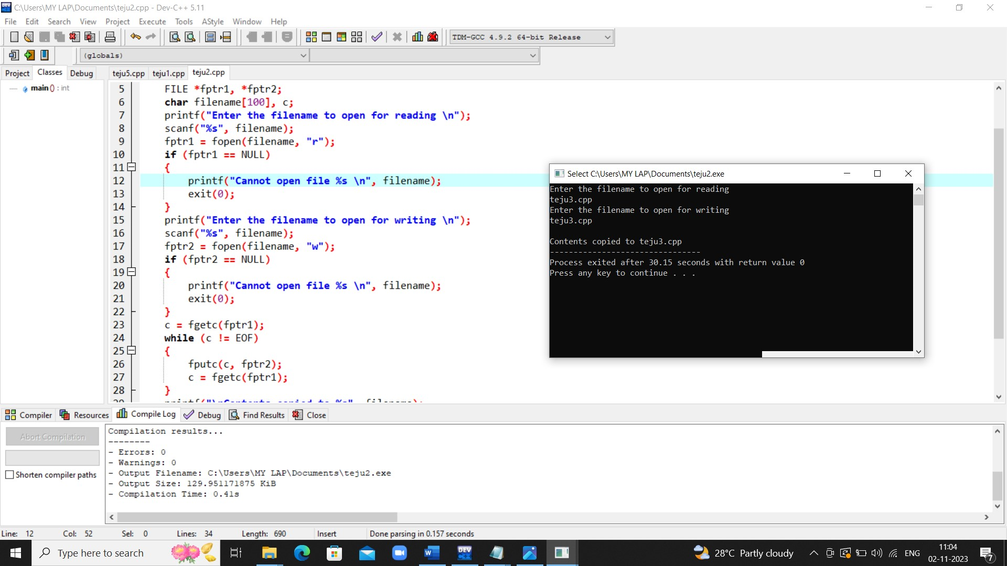

3.Design a CPU scheduling program with C using First Come First Served technique with the following considerations.

a. All processes are activated at time 0. b. Assume that no process waits on I/O devices.

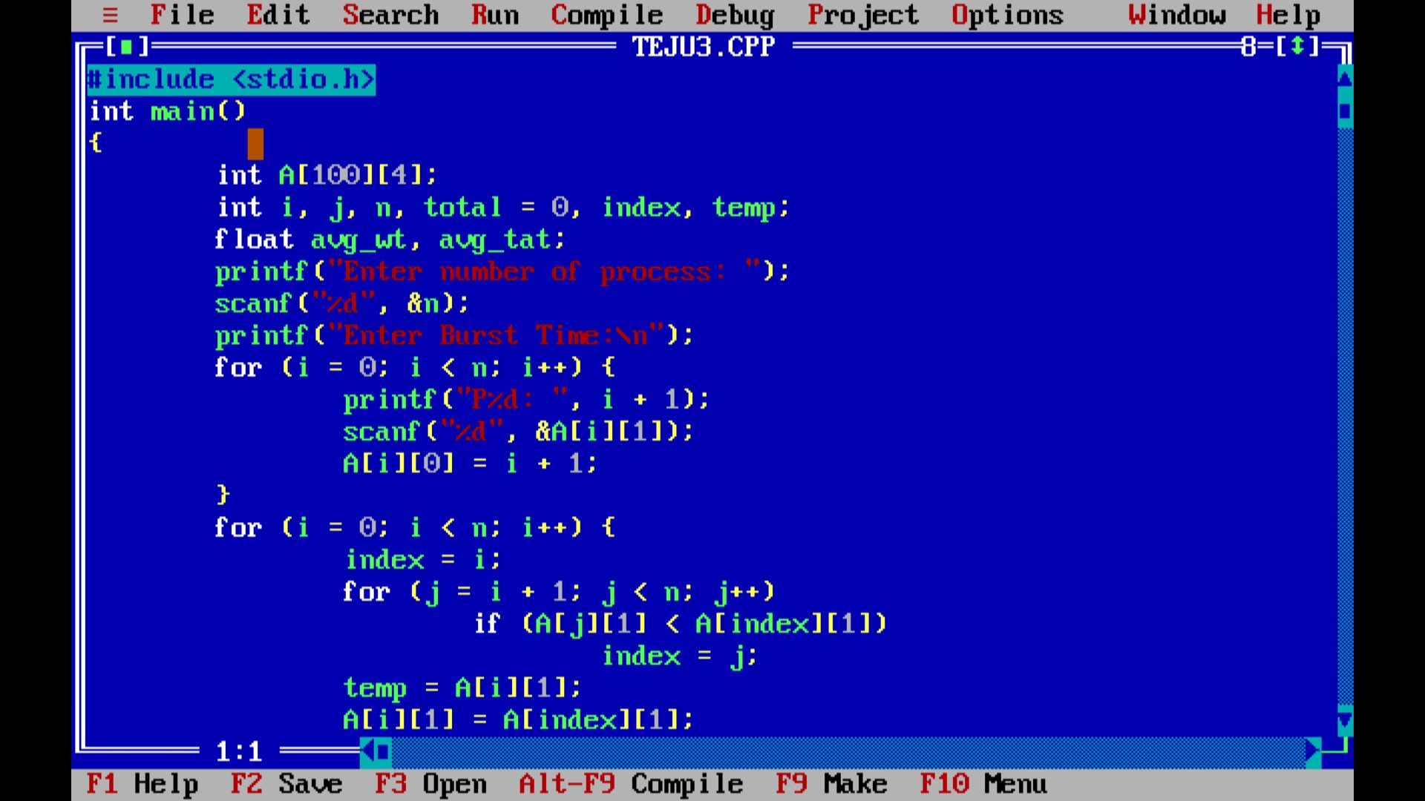

Output:-

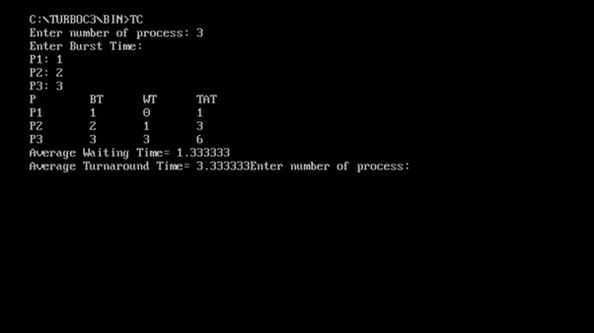

4. Construct a scheduling program with C that selects the waiting process with the smallest execution time to execute next.

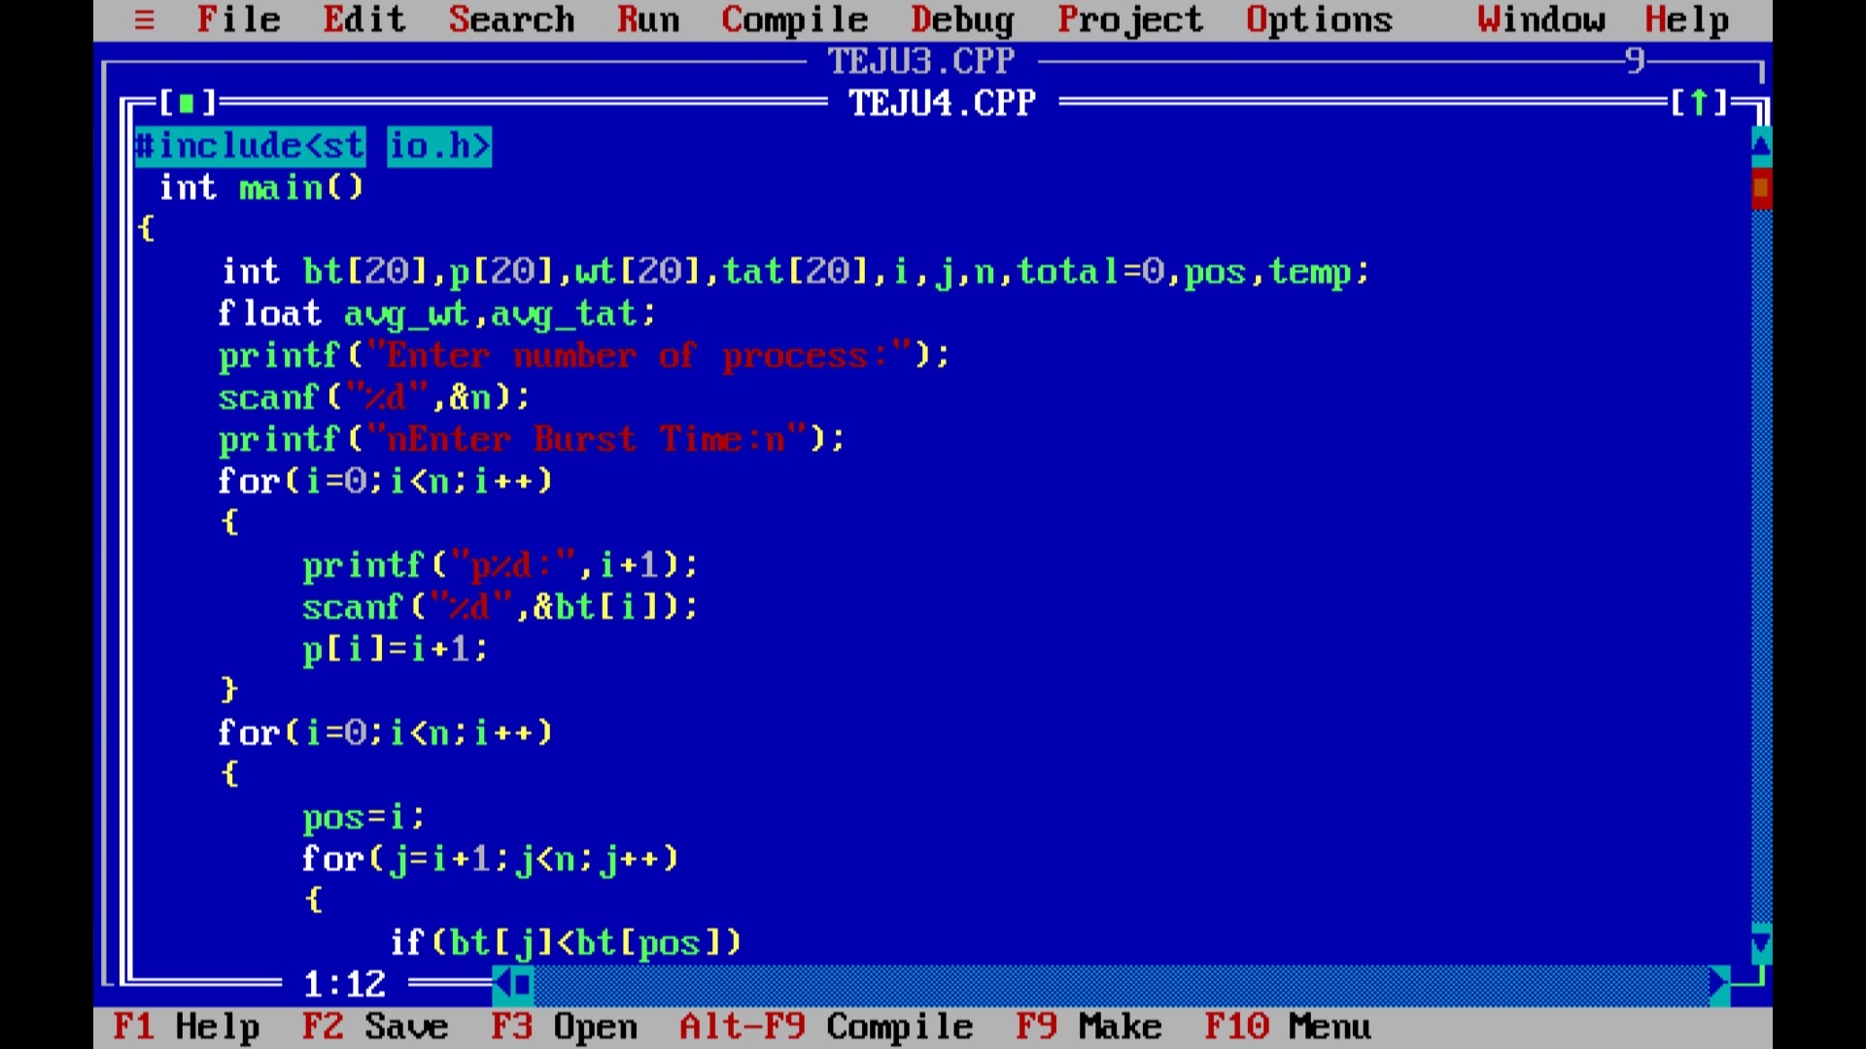

Output:-

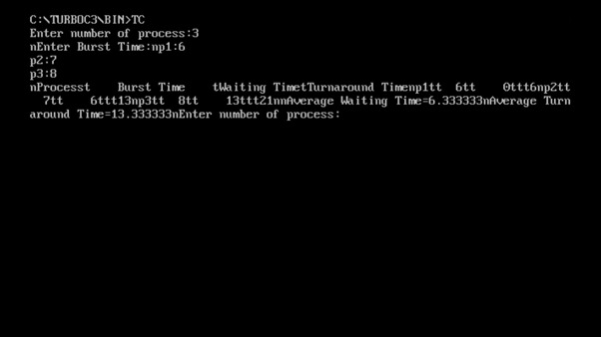

5. Construct a scheduling program with C that selects the waiting process with the highest priority to execute next.

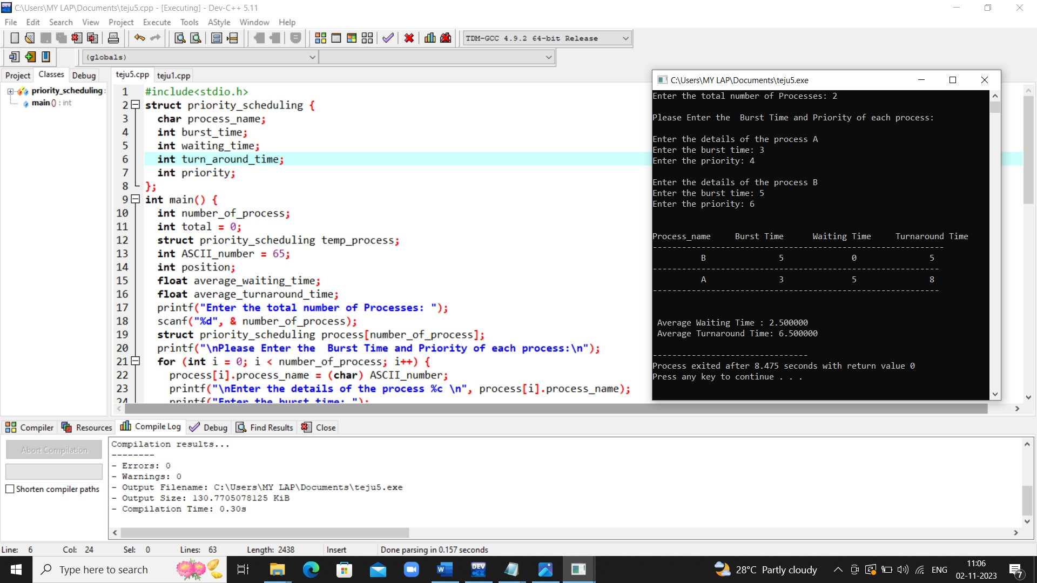

6. Construct a C program to implement pre-emptive priority scheduling algorithm.

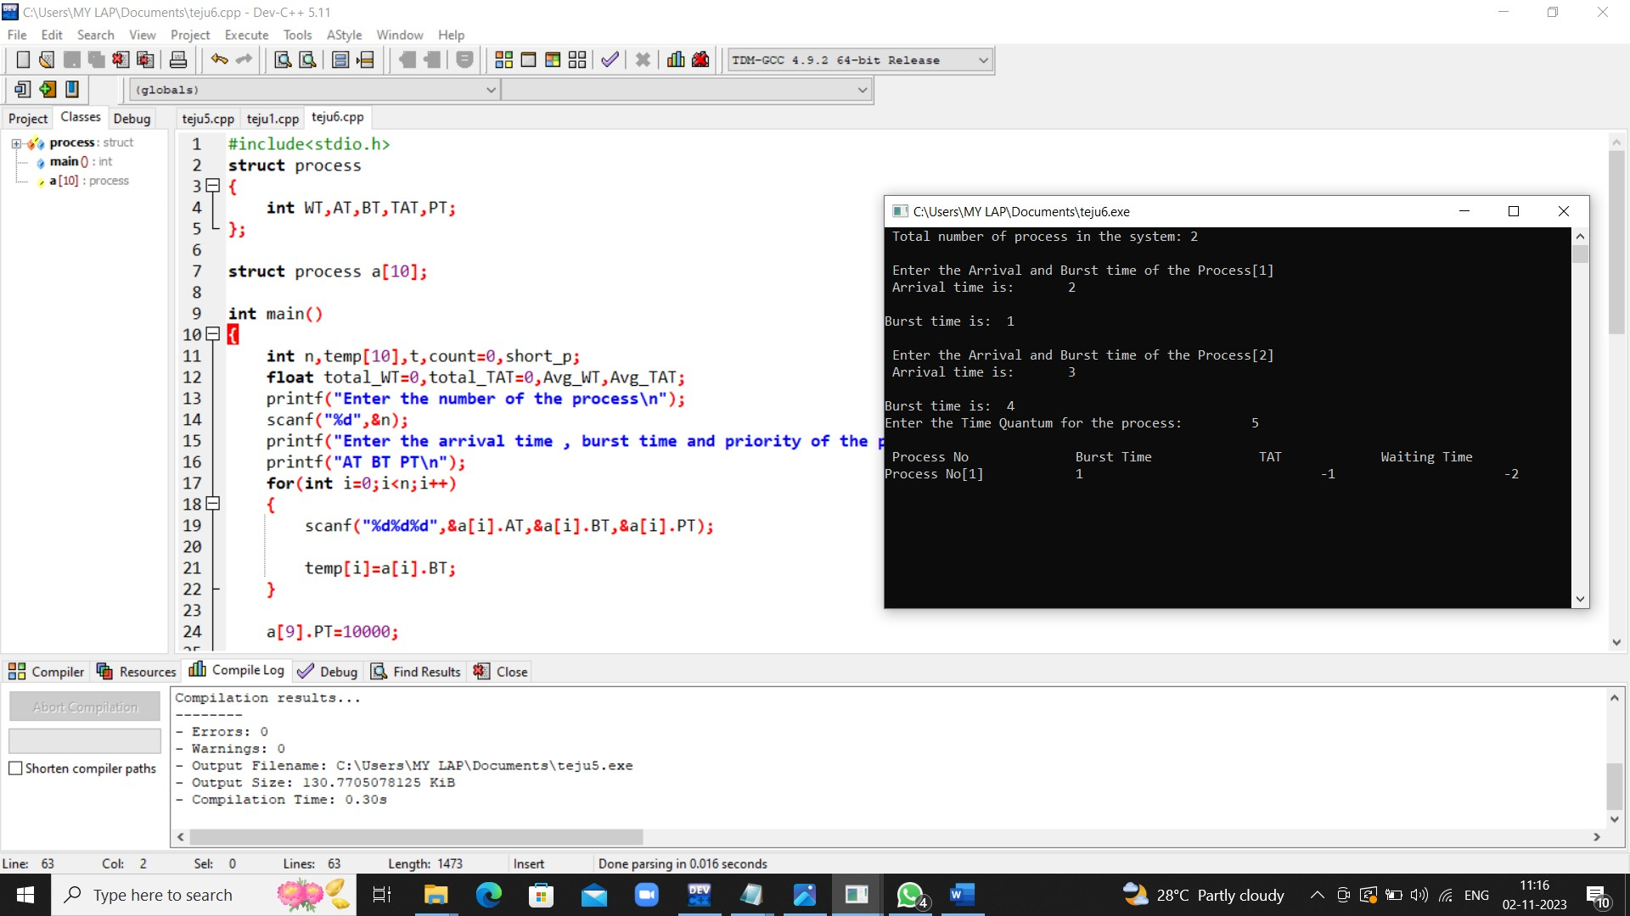

7. Construct a C program to implement non-preemptive SJF algorithm.

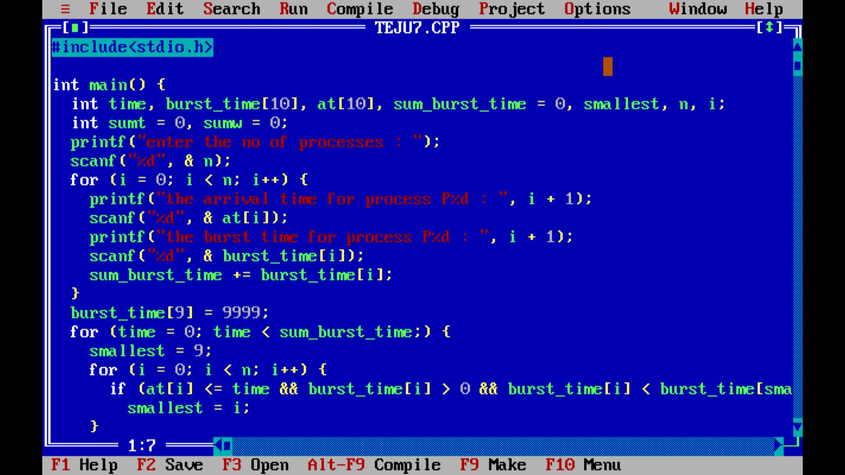

Output

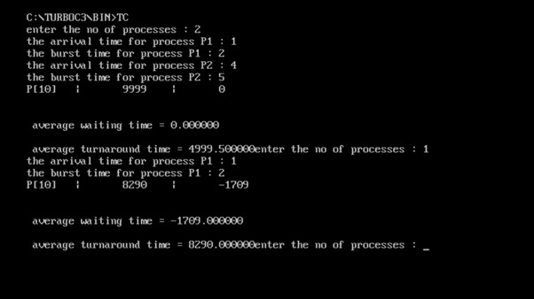

8.Construct a C program to simulate Round Robin scheduling algorithm with C.

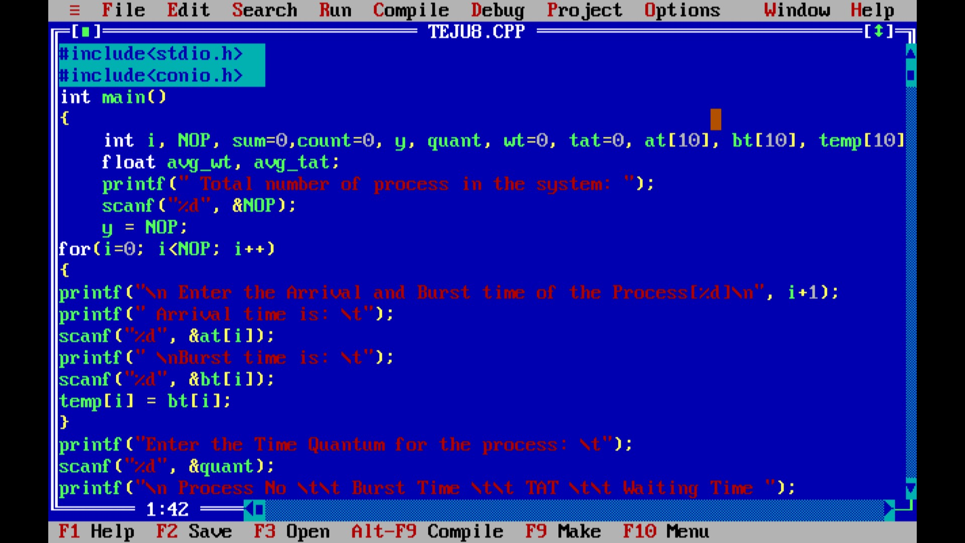

Output

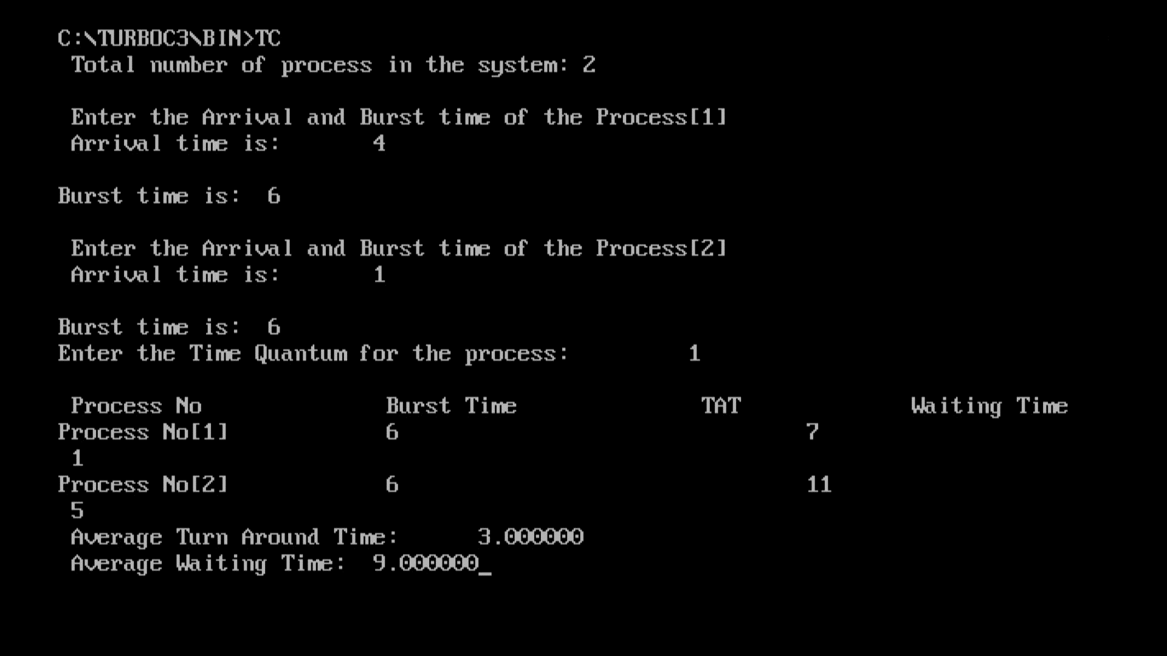

9. Illustrate the concept of inter-process communication using shared memory with a C program.

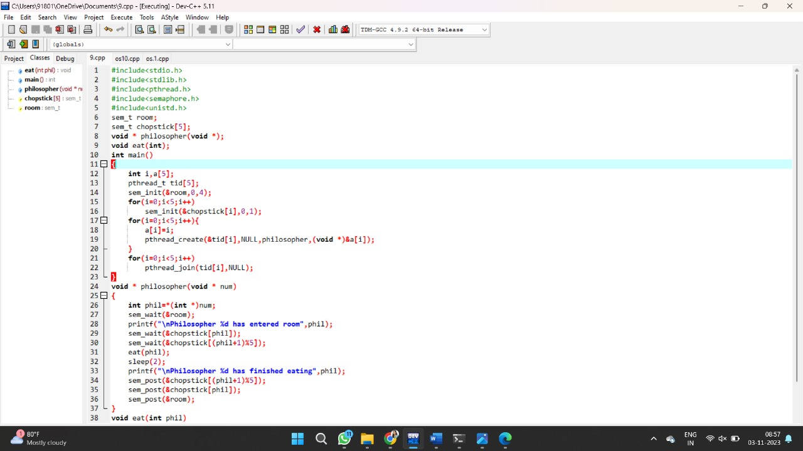

Output:-

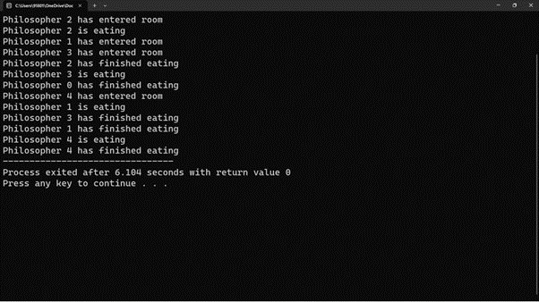

10. Illustrate the concept of inter-process communication using message queue with a C program

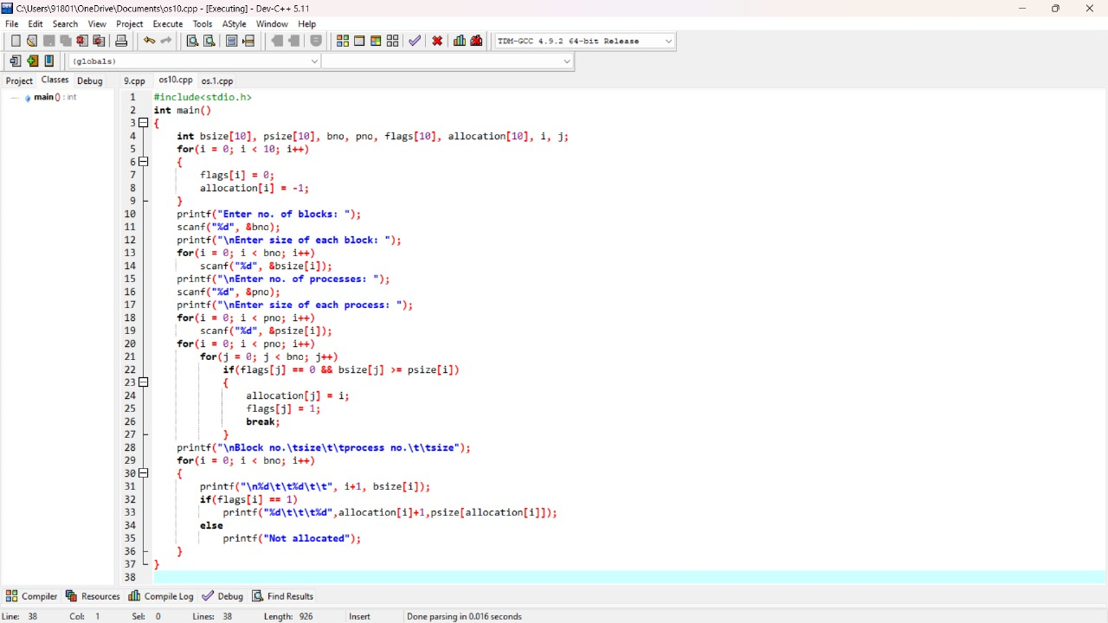

Output:-

